**Question (One) 1**

Given head, the head of a linked list, determines if the linked list has a cycle in it. There is a cycle in a linked list if there is some node in the list that can be reached again by continuously following the next pointer. Internally, pos is used to denote the index of the node that tail's next pointer is connected to. Note that pos is not passed as a parameter.

Return true *if there is a cycle in the linked list*. Otherwise, return false.

Example 1:

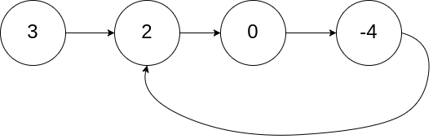

Input: head = [3,2,0,-4], pos = 1

Output: true

Explanation: There is a cycle in the linked list, where the tail connects to the 1st node (0-indexed).

Example 2:

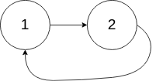

Input: head = [1,2], pos = 0

Output: true

Explanation: There is a cycle in the linked list, where the tail connects to the 0th node.

Example 3:



Input: head = [1], pos = -1

Output: false

Explanation: There is no cycle in the linked list.

Constraints:

* The number of the nodes in the list is in the range [0, 104].
* -105 <= Node.val <= 105
* pos is -1 or a valid index in the linked-list.

Follow up: Can you solve it using O(1) (i.e. constant) memory?

**QUESTION TWO (2):**

Given the head of a linked list, return *the node where the cycle begins. If there is no cycle, return* null. There is a cycle in a linked list if there is some node in the list that can be reached again by continuously following the next pointer. Internally, pos is used to denote the index of the node that tail's next pointer is connected to (0-indexed). It is -1 if there is no cycle. Note that pos is not passed as a parameter.

**Do not modify the linked list.**

Example 1:



Input: head = [3,2,0,-4], pos = 1

Output: tail connects to node index 1

Explanation: There is a cycle in the linked list, where tail connects to the second node.

Example 2:



Input: head = [1,2], pos = 0

Output: tail connects to node index 0

Explanation: There is a cycle in the linked list, where tail connects to the first node.

Example 3:



Input: head = [1], pos = -1

Output: no cycle

Explanation: There is no cycle in the linked list.

Constraints:

* The number of the nodes in the list is in the range [0, 104].
* -105 <= Node.val <= 105
* pos is -1 or a valid index in the linked-list.  **Follow up**: Can you solve it using O(1) (i.e. constant) memory?

**QUESTION THREE (3):**

Write a function that takes the head of a linked list and returns the reversed list.

class Solution:

def reverseList(self, head: Optional[ListNode]) -> Optional[ListNode]:

if head is None:

return None

stack = []

current = head

while current is not None:

stack.append(current)

current = current.next

new_head = stack.pop()

current = new_head

while stack:

next_node = current.next

current.next = stack.pop()

current = next_node

 return new_head

**QUESTION FOUR (4):**